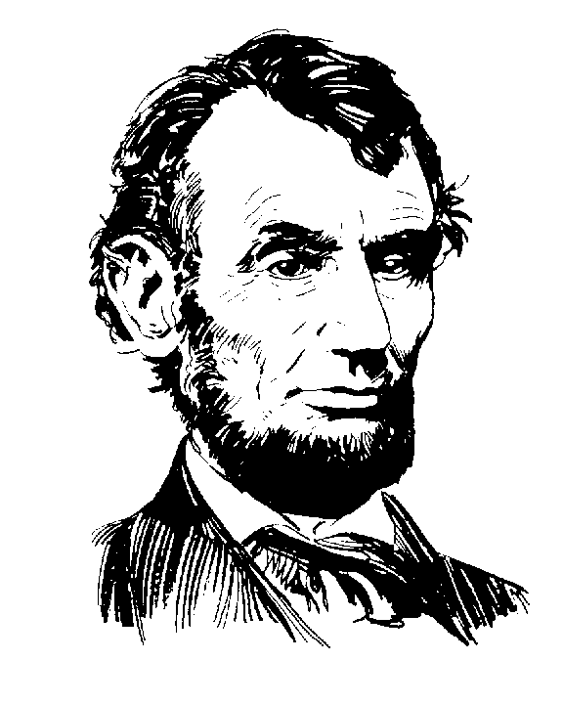
Advanced Placement
United States History
2017-18

Dear __________________________________

Congratulations! You have been accepted into the A.P. U.S. History 2016-17. You have chosen to embark on an incredible journey for next year. Get ready for the challenge and fun. Here is what you will need to complete over the summer:

- Complete reading assignment “History is a Weapon”
- Study the handout “English, French, and Spanish Colonies: A Comparison” for a quiz!
- Read article on the Colombian Exchange and answer the questions.
- Complete the Guided Notes for Chapter 1

All of these assignments are attached to this letter and links to the videos and articles are on my weebly page http://morganhistory.weebly.com/. Everything will be due on the first day of class. Please contact me at cmorgan@washoeschools.net if you have any questions.

Sincerely,

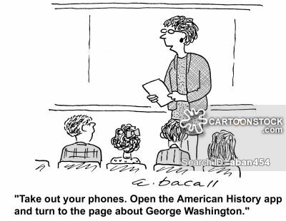
Mrs. Morgan

