APUSH – The Columbian Exchange Name: ___________________________

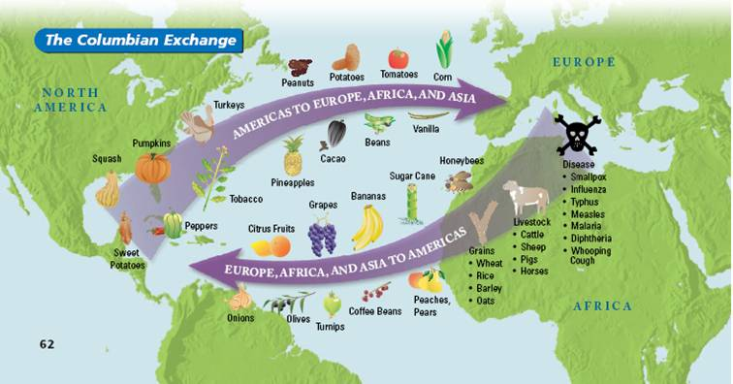
What was the most immediate biological consequence of the exchange and which group suffered most? Why?

What other kind of exchanges had a great impact on the two worlds? Explain the impact and how it changed the lives of people in both areas.

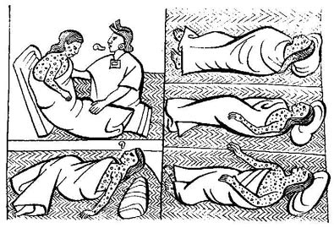
Why is it important to consider perspective when examining the ecological revolution of the Columbian Exchange?

